Social Processes

Richard Evans, Thomas Barnet Lamb
revans@lionhead.com tblamb@lionhead.com

“Today the individual has become the highest form and the greatest bane of artistic creation. The smallest wound or pain of the ego is examined under a microscope as if it were of eternal importance. The artist considers his isolation, his subjectivity, his individualism almost holy. Thus we finally gather in one large pen, where we stand and bleat about our loneliness” (Ingmar Bergman).

Today we shall be talking about social processes. We shall be answering the following questions:
- What is a social process?
- Why are they important?
- Do they really exist? How do they exist?
- How should we implement them in a computer program?

1. What Is A Social Process?

A social process covers a wide range of activities:
- A game of chess. This is a persistent process that requests its two participants to take it in turns to make a move.
- A social-group (e.g. the “rebels” at school). This group requests its participants to perform rebellious actions, and keeps track of the status of each rebel.
- The moral community. This group is watchful for violations of moral laws, and requests its members to punish transgressors. The moral community keeps track of who has made what violation to which law.

Preliminary definition:
A social process is a persistent process that contains information representing what agent(s) should do in certain situations.

2. Why Are Social Processes Important?

Adult humans have a bewildering variety of skills – different sorts of things they can do. Some of these skills are more basic than others: my ability to play cricket, for example, is founded on my hand-eye coordination, and my understanding of the rules of cricket. Let us say a skill S is foundational if there are other skills that we have because we have S. In this section we will argue that Social Processes are important because the ability to participate in them is a foundational skill, in other words: there are some things we can do that we can do because we can participate in social processes. Examples:

Understanding Language.
Wittgenstein’s language-games are examples in which someone knows what something means because he understands the social process he is in. Investigations $2: “The language is meant to serve for communication between a builder A and an assistant B. A is building with building-stones: there are blocks, pillars, slabs and beams. B has to pass the stones, and that in the order in which A needs them. For this purpose they use a language consisting of the words “block”, “pillar”, “slab”, “beam”. A calls them out; -B brings the stone which he has learnt to bring at such-and-such a call”. If someone understands what “pillar” means, he does so in virtue of understanding its role in the social process in which it is embedded.
Compassion
Wittgenstein asks “Why can a dog feel fear but not remorse? Would it be right to say “Because he can’t talk”?” [Zettel $518] The reason a dog can’t feel remorse is that he cannot participate in the moral community in such a way as to recognise or manifest remorse. It is because he cannot participate in this social process that he cannot enter into these feelings.

From an individualist, or adolescent, perspective, conforming to social pressures can seem to be an unfortunate restriction on one’s freedom. But participation in a social process enables us to make choices we couldn’t otherwise make. Unless we are participating in the game of chess, we cannot choose between castling kingside and queenside. This choice is only available to us once we have entered into the chess-playing activity. You cannot get married just by saying “I do” – these are just empty words unless they are embedded within a marriage ceremony. Social processes create new possibilities.
As well as enabling us to do things we couldn’t otherwise do, social processes also provide an organising framework for our knowledge. “Heidegger pointed out that the outer horizon or background of cultural practices was the condition of the possibility of determining relevant facts and features and thus prerequisite for structuring the inner horizon” [Dreyfus 36] In other words, we must not represent facts in one big pool, but must organise them by which social activities they are relevant to. This is the way for agents to get efficient access to what is relevant in a particular situation. “The basic insight dominates these discussions that the situation is organized from the start in terms of human needs and propensities which give the facts meaning” [Dreyfus p.262]

Objection! Couldn’t A Castaway On A Desert Island Understand Language, Feel Compassion, etc, without Participating In Social Processes?

A social process is a persistent process which contains information specifying what one or more agents should do. There is nothing wrong with a process with just one member. Someone who is performing a solitary pursuit (e.g. waiting for someone) is still participating in a social process (these processes are still “social” because they can be shared between individuals, even if they currently involve just one person).
So if the castaway has come from a society, where he has learnt to participate in the social flux, then his mental skills are foundational on his social participation in that society. But if, to change the example, he had been born on the island, and had never been involved in any social process, then it is rather hard to imagine how he could understand language. If he did, somehow, develop his own language from scratch, then he would have done this by developing norms of behaviour which he himself followed – he would, in other words, have constructed social processes for himself to follow, and these social processes would be learnable by others.

Summary and Qualifications

We have claimed that the ability to participate in social processes is a foundational skill. We have justified this claim by giving examples of skills (understanding of language, compassion) that are dependent on a participation in the social flux. Please note that we are not saying that the ability to participate in social processes is sufficient for personhood – this ability is necessary for personhood, but it is not sufficient. To be a person, we don’t just need to be able to participate in social processes, we also need to be able to understand their point:
A long time ago, the concept of ownership was introduced into our culture: people should be able to own things, and people should get punished if they mess about with things that belong to other people (without their permission). Now this social activity wasn’t created on a whim – it serves a valuable purpose: suppose you want to embark on a long-term project involving, say, decorating an object. This project would be fraught with difficulties if you had to worry about someone else coming along and messing with your project while you were asleep or away. The ongoing social process of maintaining ownership gives us a (defeasible) guarantee that we can embark on long-term projects involving objects - this is its point.
If agents are to construct new social processes, or modify existing ones, they need to understand the point of the process. We do not pursue this important idea further in this article.

3. Do Social Processes Exist? How Do They Exist?

We shall be arguing that social processes exist - they are just as real as individual beliefs and desires. Our argument will be that we need to invoke social processes in order to explain and predict how people behave.

Consider two cases of intentional action:
- Andrew spots an old friend across the street. He goes up to him, and says “Hello”. Why did he make this strange non-assertoric utterance?
- Bob is at a football match. His team scores, and he cheers. Why did he go to all the bother of clapping and shouting and getting excited like this?

We shall consider three possible explanations of such actions.

Explanation 1. Reductionist Explanation in terms of Beliefs and Desires about Other Individuals
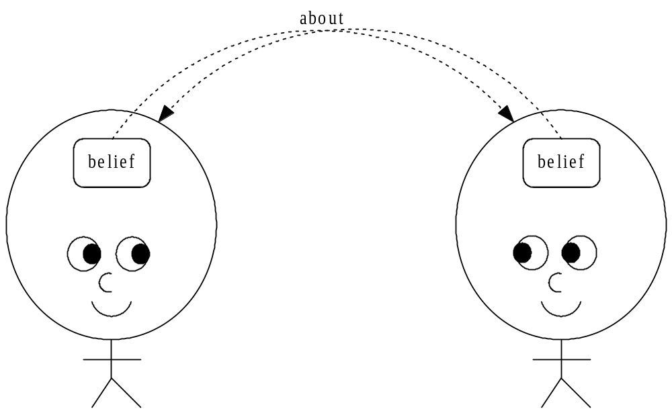

The reductionist tries to explain Andrew saying “Hello” just by referring to beliefs about other individuals, without referring to social processes at all. The idea is that we want to do what is expected of us by others:

Andrew said “hello”
because
Andrew believes there is an individual who wanted him to say “hello”,
and Andrew wanted to do what that individual wants him to do.

Or more generally:
X φs
because
There is a Y who wants X to φ, and X wants to do what Y wants him to do.

The trouble is, saying this results in an explanatory dead-end - there can be no forthcoming explanation of why the other person wanted him to do it.

A much more plausible explanation involves beliefs which are about the social processes themselves:

Explanation 2. Explanation in terms of Beliefs and Desires about Social Processes

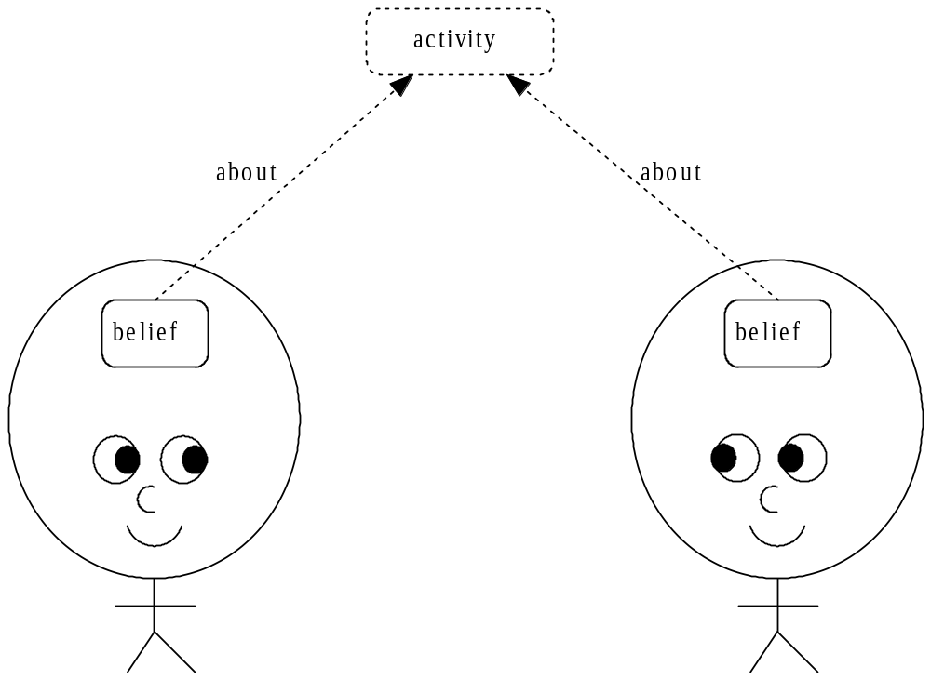

Now agents have beliefs about social processes, and these beliefs can guide action.
For example:

Bob cheered
because
he believed his team had scored,
and believes his team wants him to cheer when they score
(he is a fan, after all)

Or more generally:
X φs
because
X believes there is a social process A which requests X to φ,
and X wants to do what he believes A requests him to do
(this is what it means to be “in” the social process)

This explanation assumes agents have beliefs about social processes, but does not assume these processes actually exist. This picture is compatible with the following:
- Although people have beliefs about social processes, all these beliefs are systematically false because there are no such things as activities.
- Social activities exist, but are abstract, causally inert entities, like numbers or configurations of numbers.
But although they are compatible, we shall argue that both these propositions are false.

Explanation 3. Explanation in terms of Requests from Social Processes

In this picture, social processes are real objects which act in the world by requesting agents to do things:

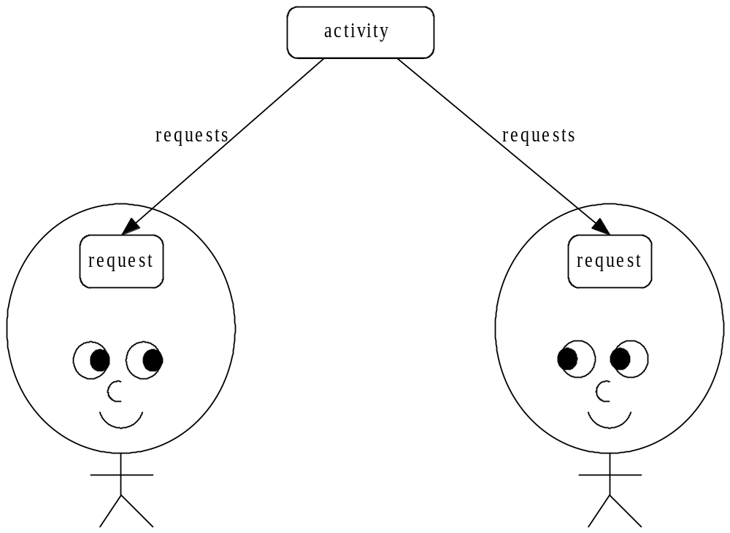

In a moment we shall argue that both explanations (2) and (3) are true, that (3) is a higher-level explanation, and sometimes the only available option because of its informational economy. But first we shall consider the immediate objections to this realist picture:

Objection 1 to Explanation 3: Argument from Queerness.

There is something initially unintuitive about these strange non-physical entities which somehow have causal effects on agents in the world. But if this “argument” from queerness is going to be anything more than an expression of incredulity or puzzlement, then our objector needs to ask some specific questions. In particular:
- How can non-physical entities have causal effects on agents?
- How do they act at a distance?
- How do these strange entities come into being?

Objection 1.1 How can Non-Physical Entities have Causal Effects on Agents?

Social Processes are not entirely non-physical entities: they contain the individuals who are participating in them. The set containing Jack and a rock is, in a sense, a physical entity: it could not exist without the existence of those particular physical entities. A social process has mixed ontological status: it is composed of both physical objects and abstract symbols.
Further, social processes do not have causal effects on agents: social processes do affect agents, but they do not do so causally – it is not as if the social process first requests an agent to do something, this message travels through the air waves, and then the agent hears the request, and processes it. Rather, it is the fact that the agents believe the activity has requested them that makes it the case that the social process requested them. Analogy: the fact that the water is boiling doesn’t cause the molecules to be whizzing around – but just that the water couldn’t be boiling unless the molecules were so moving around.

Objection 1.2 How do Social Processes Act at a Distance?

Social processes do not act at a distance. In our diagrams, we have, admittedly, drawn the social process as a “cloud” floating above the agents, but what is actually going on is that the social processes envelop the agents – there is no action at a distance because the process is right there, with the agents inside it.

Objection 1.3 How do Social Processes Come Into Being?

Social processes do not just spring up, as if by magic. They come into existence once agents have beliefs about them. Their existence is dependent on those beliefs.

Objection 2 to Explanation 3: Psychological Inauthenticity.

There is another sort of worry about explanation 3 – it turns the agents from active agents in the world to passive receptors of social processes. “Surely activities are something we do, not something that do us!” This is a reasonable objection that must be answered if explanation 3 is to have any psychological plausibility.
If the social process dictated what the agents did, then indeed this picture would have taken all the autonomy out of the individual. But we propose an alternative interpretation of the downward arrows: the social processes merely request the agents to do something: an agent may be participating in a number of different social processes simultaneously, and chooses which request to go with. The range of choices is given to him by the world, but the decision is still his, and his alone, to make.

Now that we have disposed of the most immediate objections to the realist picture, we will present a positive argument for the necessity of explanation (3).

Argument for Necessity of Explanation 3.

A crowd of football fans are at a match when their team scores. They cheer. What explains their cheering?
We could explain this in terms of the beliefs of the individual crowd members (explanation 2): they all believed a goal had been scored, and wanted to cheer when a goal was scored. This explanation assumes that a goal being scored is an atomic, physical event, in need of no explanation. But when we start to unpack what it is for a goal to be scored – that the ball must have been kicked while no-one was off-side, that the ball must have been in play when the ball was kicked – we see that there is essential reference to the state of the football match in any unpacking of what it is for a goal to be scored. Each of our crowd members, in other words, need to have a belief about a whole social process, in order to understand that a goal has been scored.
Let us look at explanation 2 in terms of its informational size. Assume there are 1000 people in the crowd, and the state of the football match can be expressed in 2¹⁰ bits. Then this explanation costs 1000 * 2¹⁰ bits.
Now let’s look at the information size of explanation 3. We explain the crowd cheering by invoking one social process with 1000 members. If an individual can be uniquely identified in 2⁴ bits, then explanation 3 costs 2¹⁰ + 1000 * 2⁴ which is approximately equal to 1000 * 2⁴ bits.
Explanation 3 is 2⁶ times more informationally compact. This saving gets even larger when we consider explanations of sequences of actions: suppose the crowd cheered when a goal was scored, and later booed when one of their players was sent off. Explanation 2 would use 2000 * 2¹⁰ bits to explain this sequence of actions, whereas Explanation 3 would use just 2*2¹⁰ + 1000 * 2⁴.
We have justified the “social stance” in a manner similar to the one Dennett uses to justify the intentional stance: we are committed to the existence of entities if we have to invoke them in explanation and prediction (notice this is not the “have” of hard, logical necessity, but the “have” of practical necessity).

Summary of Section 3

We have rejected the reductionist explanation, but have endorsed both explanations 2 and 3:

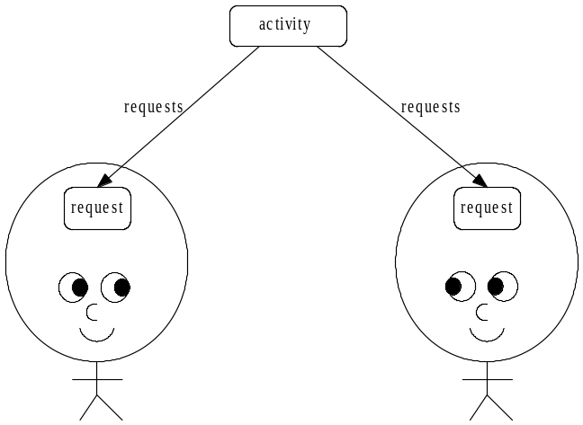

Both explanations 2 and 3 are true. Explanation 3’s truth is dependent on the truth of Explanation 2, but Explanation 3 is much more informationally compact.

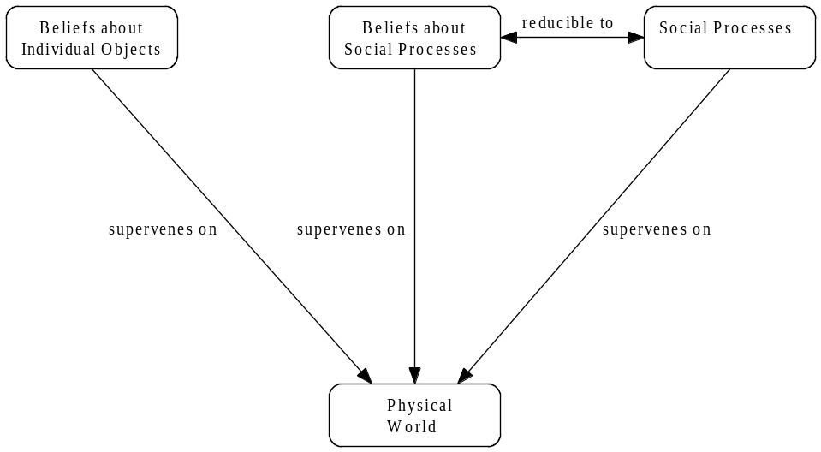

4. Computational Implementation

When building a simulation of a society of agents, there are many different levels at which we should be able to add new content – we must be able to add new objects, animations, actions, goals to the simulation, without having to do the book-keeping by hand.

When building an agent simulation, there is no magic formula or technique to generate plausible agents, there is just lots of different behaviour to simulate. Each bit of behaviour needs to be easily-addable; behaviour needs to be addable at lots of different levels. The sophistication of a simulation is a function of the number of levels at which we can easily add content.

The next level at which we should be able to add content is the level at which we create new social processes.

Definition:
A social process is a non-physical entity which exists in the world, which influences the behaviour of the agents who are participating in it. At any time, the social process is in a particular state, and this state determines what sort of requests it makes of its participants. The social process does not command its participants to obey – it just requests that they perform an action, and tells them the consequences of ignoring this request. The agents themselves decide which requests to listen to, based on their evaluation of the consequences of performing the various options.

A few examples of social processes:
- Games (with winners, and without winners)
- Romantic attachments
- Conversations
- Marriages
- Households
- Social groups (eg: the “in crowd”, “the nerds”)
- Meals

Notice some of these activities, like a meal, are short-lived, but others are extremely long-term: a family lasts as long as there is anyone in it.

These activities group people together, and these groupings can overlap:

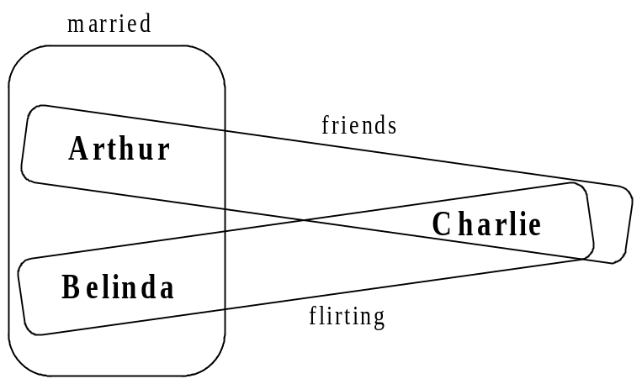

In this dramatically charged example of activity-overlap, Arthur and Belinda are married. Arthur and Charlie are friends, but Belinda and Charlie are flirting.

Example Activity

BuilderOrderingHelperToBringBrickOfCertainShape(GAgent builder, GAgent helper)
{
needs builder, helper
constructor
{
string BrickTypeText[NUM_BRICK_TYPES]=
{
"Cube",
"Brick",
"Slab",
"Beam",
"Column"
};
STRINGINT_MAP BrickTextType;
BrickTextType["Cube"]=CUBE;
BrickTextType["Brick"]=BRICK;
BrickTextType["Slab"]=SLAB;
BrickTextType["Beam"]=BEAM;
BrickTextType["Column"]=COLUMN;
-> WaitForMessages
}
state WaitForMessages
{
handle BuilderNeeds(BRICK_TYPE brick_type)
{
-> BuilderNeeds(brick_type);
}
handle SomeoneSays(GAgent s, AGENT_LIST audience, STRING_LIST words)
{
if(s==builder)
{
brick_type_text=words.first();
BRICK_TYPE brick_type=BrickTextType[brick_type_text];
-> BuilderAsksFor(brick_type);
}
}
}
state BuilderNeeds(BRICK_TYPE brick_type)
{
string brick_text=BrickTypeText[brick_type];
requests
builder do SAYS_TEXT(helper, brick_text) !-> BuilderRefused
->
WaitForMessages
}
state BuilderAsksFor(BRICK_TYPE brick_type)
{
requests
helper do BRING_BRICK_TO(brick_type, builder) !-> HelperRefused
->
WaitForMessages
}
state BuilderRefused
{
// very forgiving!
-> WaitForMessages
}
state HelperRefused
{
// very forgiving!
-> WaitForMessages
}
}

Social Processes in More Detail

A social process defines a state hierarchy:

Name(Parameter₁, … Parameter_{N}) {
State1:
State 1.1:
…
State 1.1.1
…
State 1.1.2
…
State 1.2
State 1.2.1
…
}

Each particular state can have its own parameters, its own preconditions, its own message handling, its own local variables with initialisations, its own actions, and its own sub-states.

Needs

Needs conditions specify what needs to be true for the process to remain in this state, and what state to switch into if circumstances change. If we are in a particular state, all needs conditions in all parents states are checked before checking our own particular state’s. If we have the state tree:

S1:
needs 1
S2:
{
needs 2
..
}
S3:
…

and we are in state S2, then needs1 will be checked, followed by needs2.

Requests

The only way a social process can affect the game-world is by issuing a request to an agent. Request statements ask agents if they wouldn’t mind performing actions, and waits to find out if they actually bother to perform these activities.

A requests statement will appear in a state of the form:
// needs conditions
requests
agent1.action1 !⇒ Rejection(1)
…
agentN.actionN !⇒ Rejection(N)
→
Finished
{
// actions to perform while waiting
}
The first time this state is entered, the requests are passed to the agents concerned. From then on, we wait to see if any agent rejects the request, if so the rejection message is passed. If all agents finish their requested activities, state moves to Finished.

Messages

Messages are a way for social processes to communicate without having to knowing each other’s implementation details. Processes respond to messages using message-handlers. A message can have various parameters which are passed to the handler. If a message is passed to a process, the handler function is called immediately. The handler may or may not change the state of the process. Messages can be defined at any level of the state hierarchy – handlers lower down the chain take priority over more general handlers.

Requirements for an Implementation of Social Processes

Our implementation of social processes must satisfy these requirements
- It must be easy to add new social processes
- Processing activities must be fast
- They must be easily debuggable
Already these requirements seem almost incompatible: if activities must be efficient and debuggable, they should be written in C++ so we can use the existing optimisation and debugging tools, but if they are written in C++ it won’t be very easy for content authors to add a new process, because it will require a programmer. If, on the other hand, a social process is defined in a text file in a nice easy-to-use language, then content authors will be able to add new activities easily, but we lose the optimisation and debugging tools which C++ gives us. What to do?
The solution we have adopted is to define a new process in a text-file, in a special-purpose easy-to-use language, but when this process is parsed, c++ files are generated. This way we get the best of both worlds!

Implementation: Overview
A new social process is defined in a text file. When it is parsed, a new c++ activity is defined in cpp and header files. This activity inherits from the base Activity class.

Base Activity Class

virtual void Process()=0;
… … … …

inherits

creates

New Activity Definition
New Activity
Text file
cpp file
header file
creates

5. Related Work & Conclusion

Agre and Chapman’s Pengi program is based on Heideggerian ideas about the way information is organised by what agents want. Both their work and the Social Process framework fall under the slogan “Take that hippy continental philosophy, and type it in”.

The Social Process framework can be seen as a generalisation of Agre and Chapman’s work:
- In Pengi, information is organised by what individual agents want
- In Social Processes, information is organised by what social processes want

The first is a special case of the second (as long as social processes with only one agent still count as valid social processes).

In this article, we have tried to motivate the introduction of social processes as the next obvious level at which to add content, and we have outlined a working system which makes it very easy to add a new social process (without having to worry about all the book-keeping needed to integrate our new process with all the others). In our prototype, we already have a large number of activities running simultaneously: various games (both turn-taking games and games with simultaneous-turns), conversations, meal-times, courtship activities, with a moral community process running in the background.

This work has been inspired by philosophers (Wittgenstein and Dreyfus) who are apparently critical of the very possibility of AI. It is pleasantly ironic that their work, which they might see as precluding the possibility of AI, will result in the next generation of social agents.

More generally: the critic of the possibility of AI is impaled on an uncomfortable dilemma – either he specifies clearly what aspect of persons it is that computer agents cannot replicate, or he does not. If he doesn’t, he has not justified his impossibility claim, and could be accused of being lame or woolly; but if he does, he runs the risk of being sufficiently specific about what exactly it is that computer agents don’t do that it can be typed in and implemented.

References

Agre and Chapman, 1987
PENGI: An implementation of a theory of activity. In Proceedings of the Sixth National Conference on Artificial Intelligence (AAAI-87), pages 268-272, Seattle, WA.

Dreyfus, 1992
What Computers Still Can’t Do, MIT Press

Hacker, 1993
Wittgenstein: Meaning and Mind, Blackwell

Heidegger, 1926
Being and Time, Harper Collins

Wittgenstein, 1958
The Blue and Brown Books, Blackwell

Wittgenstein, 1953
Philosophical Investigations, Blackwell

Wittgenstein, 1967
Zettel, Blackwell

I am indebted to Tom Smith for many of the most important points of all.
This definition will be refined in Section 4
There are lots of other expressions that more or less describe what we are going to be talking about (“group mind”, “group dynamic”, “vibe”), but each of these expressions is unsatisfactory in different ways. The expression “group mind” assumes that a social process is itself an agent, and this is rather a big assumption to smuggle-in at this early stage when we are just trying to introduce terminology. “Group dynamic” is much better because it stresses that what we are talking about is a persistent process, which changes state through time, but the use of the word “group” implies (to some)“two or more people”, and we will not want to rule out social processes with only one participant. “Vibe” avoids theory-laden assumptions, but is too strongly associated with a certain sandal-wearing 1960s counter-culture. Wittgenstein introduced the term “Lebensform”, meaning “form of life”.
In other words, ∃s: skill. ∃a: social_process. ∀x: person. Has(x,s) because CanParticipateIn(x,a)
In other words, ability to participate in social processes is a necessary condition for being a person. We are not arguing that it is a sufficient condition – we are not saying that ∀s: skill. ∃a: social_process. ∀x: person. CanParticipateIn(x,a) ⇒ Has(x,s)
“Being-with is an existential characteristic of Dasein even when factically no Other is present-at-hand or perceived. Even Dasein’s Being-alone is Being-with in the world”. Heidegger, Being and Time, $26.
Section 4 will sketch a working computer program involving agents participating in social processes, but in the current implementation these agents do not understand the overall purpose of the social processes in which they are engaged, so they have only taken the first step on an interesting journey towards personhood
Heidegger talks about the way we can lose our sense of self when we succumb to social pressures: “because the “they” presents every judgement and decision as its own, it deprives the particular Dasein of its answerability…It was always the “they” who did it, and yet it can be said that it has been no-one. Thus the particular Dasein in its everydayness is disburdened by the “they”” Heidegger, Being and Time, $27. This idea (of failing to make a genuine decision, and just going along with what a social process requests) is now such a commonplace that there are various expressions to describe it, e.g. “jobsworth” – someone who blindly does what his job expects him to do, without making a genuine decision, without thinking about the consequences.
Section 4 discusses this important point in greater detail.
It is possible to predict or explain the behaviour of a chess computer without reference to intentional states, but life is too short. (See Dennett, Intentional Systems – “we find it convenient, explanatory, pragmatically necessary for prediction”).
[Agre & Chapman 1987]
See Section 2 – Objection.
A process with only one agent is social because other agents could join at any time.

